**Machine Learning .Net Workshop – Singapore Polytechnics**

1. Open your Visual Studio 2017.
2. Go File > New Project

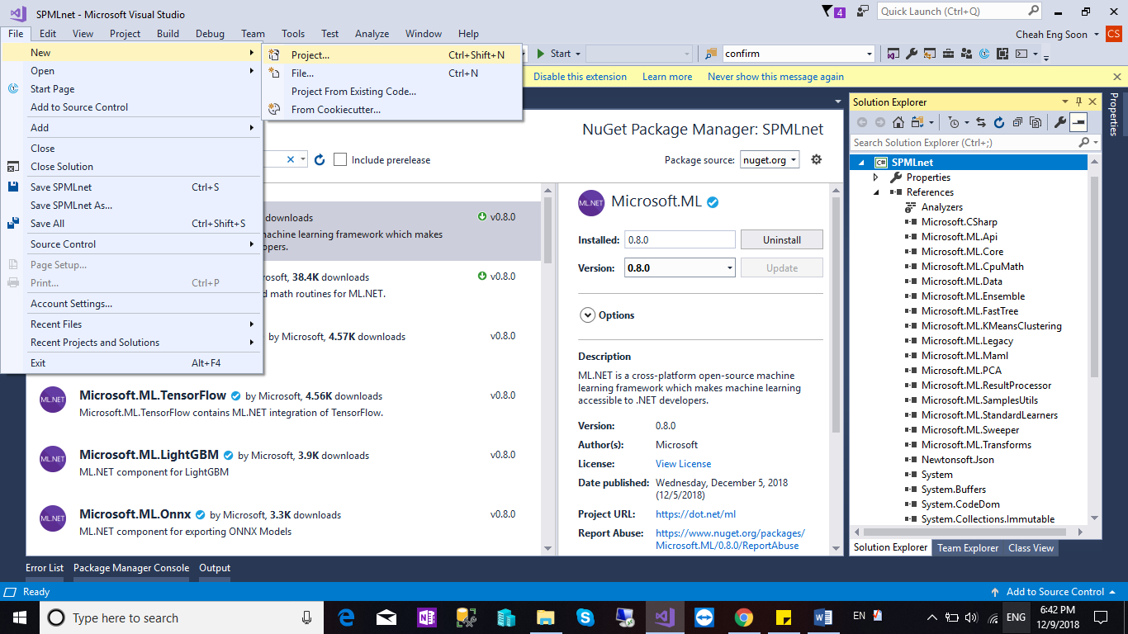

1. Select Console App and Name of your application. Lastly, Click OK.

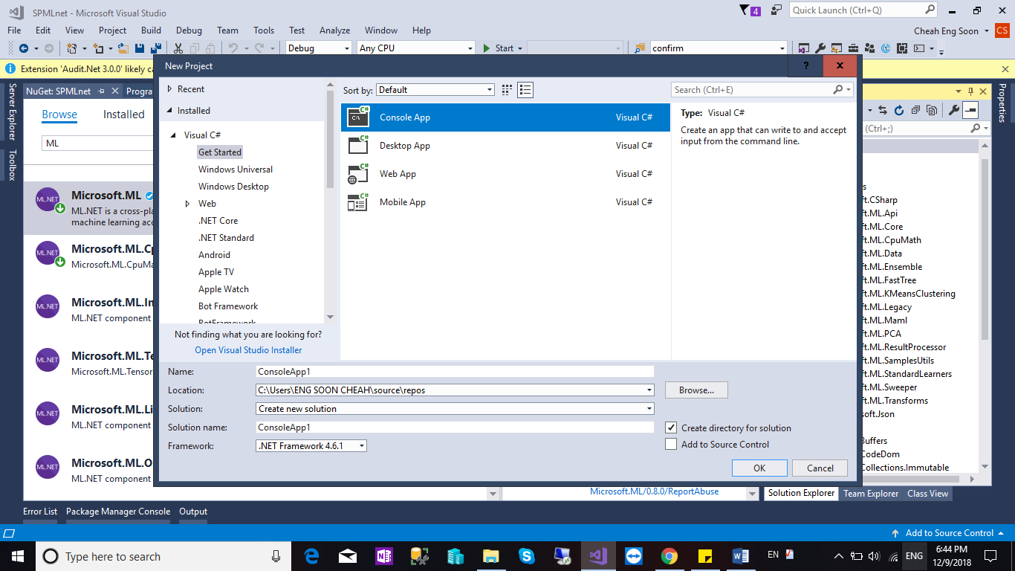

1. Go to your Solution , Right Click and Select Manage Nuget Packages.

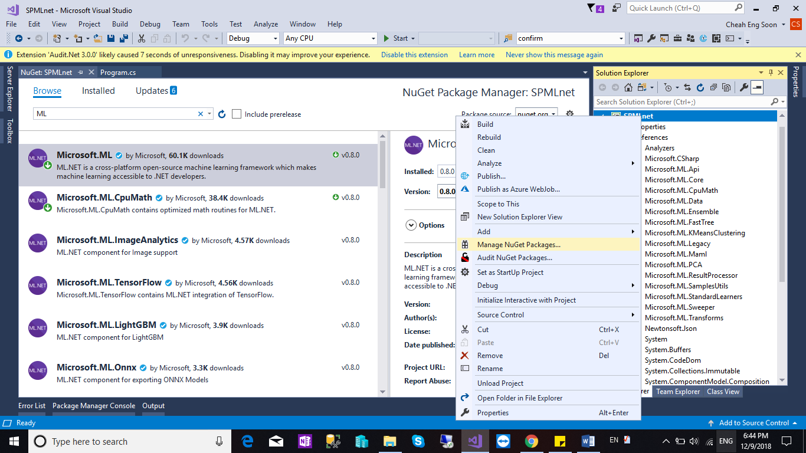

1. Browse and Search for Microsoft.ML and Click Install.

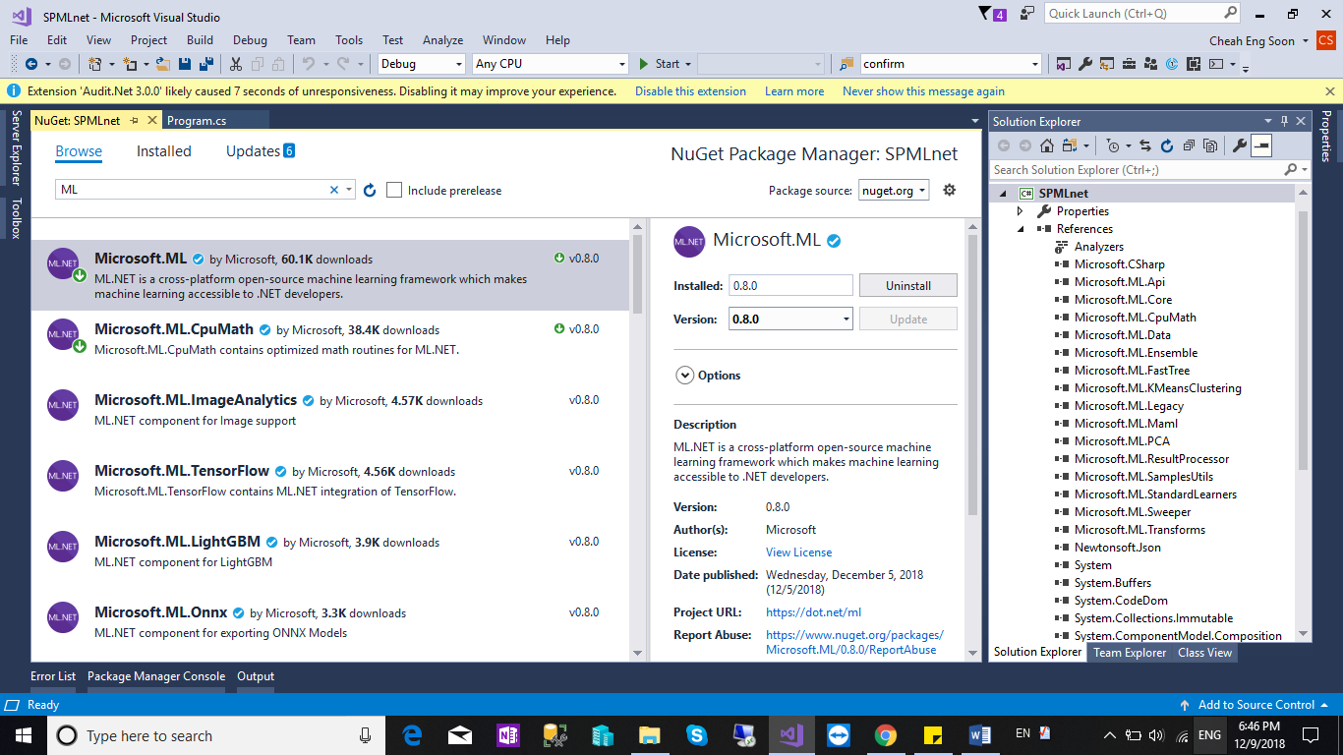

1. Back to Solutions file, right click > Add > New Folder and Name the Folder as “Data”.

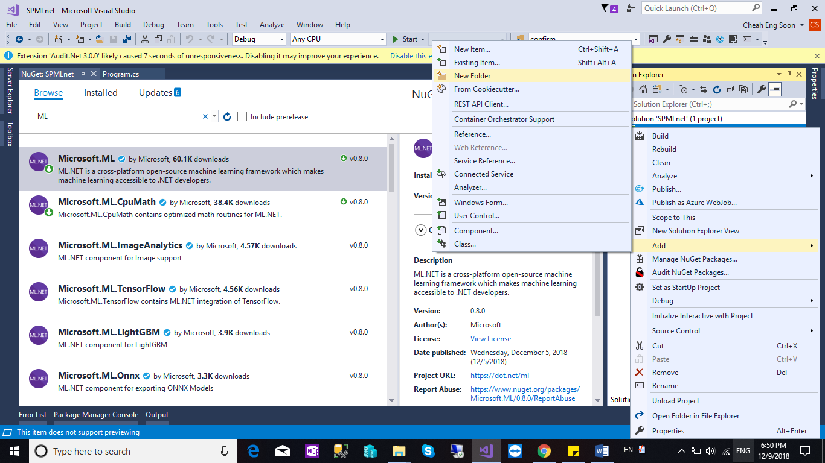

1. Download the Data from My GitHub “custTrain.csv” and put into the custTrain.csv

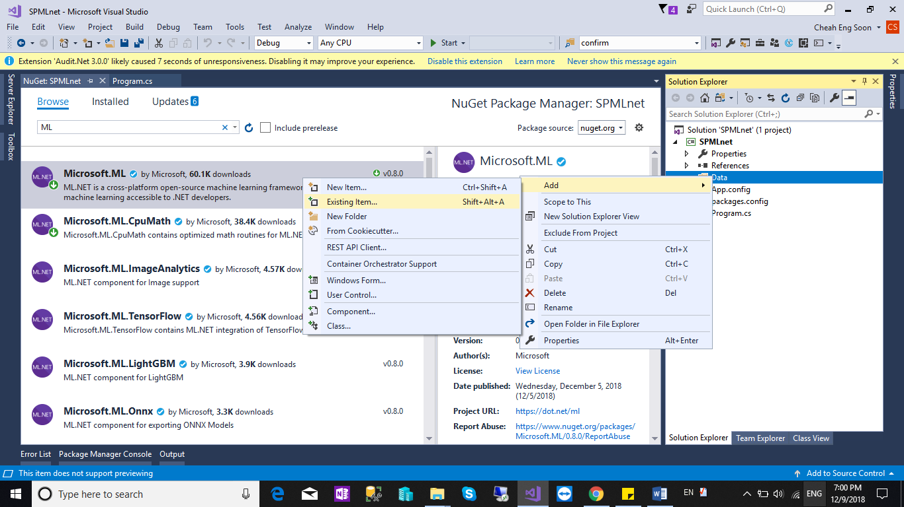

1. Select “custTrain.csv” and Select Properties. In the Copy to Output Directory, Select “Copy Always”.

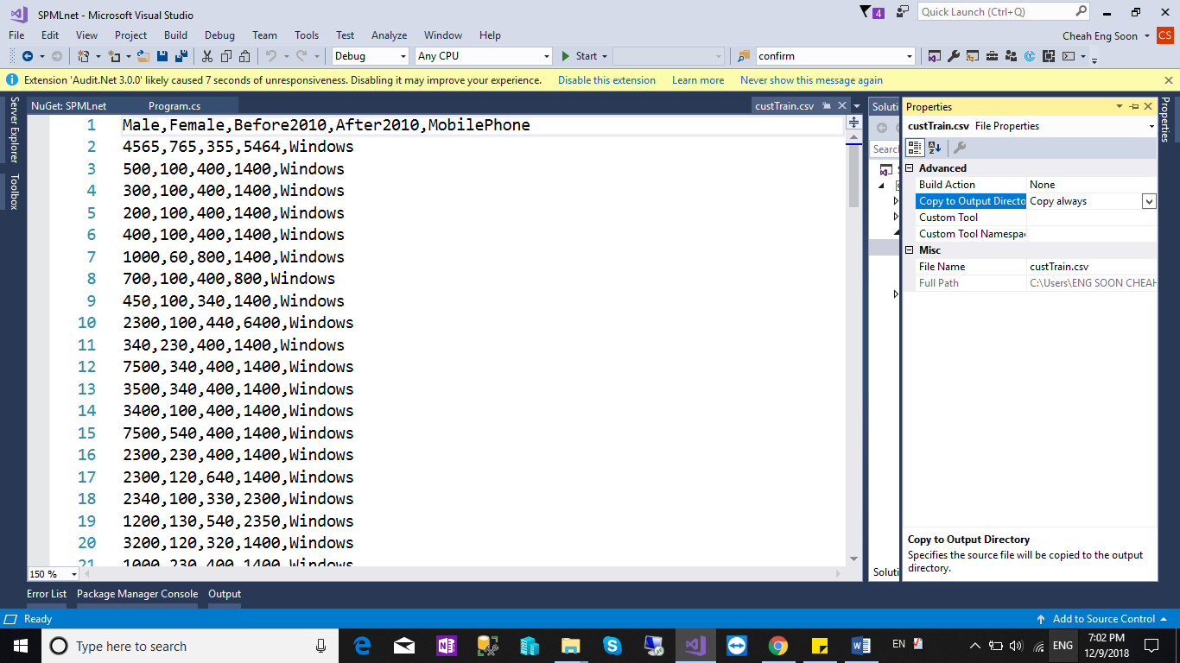

1. Right Click your solution file again > Add > New Item > Select “Class” & name the class as “CustData.cs”. and lastly paste the source code as below.

using System;

using System.Collections.Generic;

using System.Linq;

using System.Text;

using System.Threading.Tasks;

using Microsoft.ML.Runtime.Api;

namespace MLClustering

{

class CustData

{

[Column("0")]

public float Male;

[Column("1")]

public float Female;

[Column("2")]

public float Before2010;

[Column("3")]

public float After2010;

}

public class ClusterPrediction

{

[ColumnName("PredictedLabel")]

public uint PredictedCustId;

[ColumnName("Score")]

public float[] Distancessdfsd;

}

}

1. Go to “Program.cs” and replace the code as below.

using Microsoft.ML.Legacy;

using System;

using System.Collections.Generic;

using System.IO;

using System.Linq;

using System.Text;

using System.Threading.Tasks;

using Microsoft.ML.Legacy.Data;

using Microsoft.ML.Legacy.Trainers;

using Microsoft.ML.Legacy.Transforms;

using MLClustering;

namespace SPMLnet

{

class Program

{

static readonly string _dataPath = Path.Combine(Environment.CurrentDirectory, "Data", "custTrain.csv");

static readonly string _modelPath = Path.Combine(Environment.CurrentDirectory, "Data", "custClusteringModel.zip");

static async Task Main(string[] args)

{

PredictionModel<CustData, ClusterPrediction> model = await Train();

var prediction = model.Predict(TestCustData.PredictionObj);

Console.WriteLine($"Cluster: {prediction.PredictedCustId}");

Console.WriteLine($"Distances: {string.Join(" ", prediction.Distancessdfsd)}");

Console.ReadLine();

}

public static async Task<PredictionModel<CustData, ClusterPrediction>> Train()

{

// Start Learning

var pipeline = new LearningPipeline();

// Load Train Data

pipeline.Add(new TextLoader(_dataPath).CreateFrom<CustData>(useHeader: true, separator: ','));

// </Snippet6>

// Add Features columns

pipeline.Add(new ColumnConcatenator(

"Features",

"Male",

"Female",

"Before2010",

"After2010"));

// Add KMeansPlus Algorithm for k=3 (We have 3 set of clusters)

pipeline.Add(new KMeansPlusPlusClusterer() { K = 3 });

// Start Training the model and return the model

var model = pipeline.Train<CustData, ClusterPrediction>();

return model;

}

}

}

1. Right Click your solution file again > Add > New Item > Select “Class” & name the class as “TestCustData.cs”. and lastly paste the source code as below.

using MLClustering;

using System;

using System.Collections.Generic;

using System.Linq;

using System.Text;

using System.Threading.Tasks;

namespace SPMLnet

{

static class TestCustData

{

internal static readonly CustData PredictionObj = new CustData

{

Male = 300f,

Female = 100f,

Before2010 = 400f,

After2010 = 1400f

};

}

}

1. Right Click your solutions file and Select “Properties”> go to Build Tab > change the Platform target to “x64”.

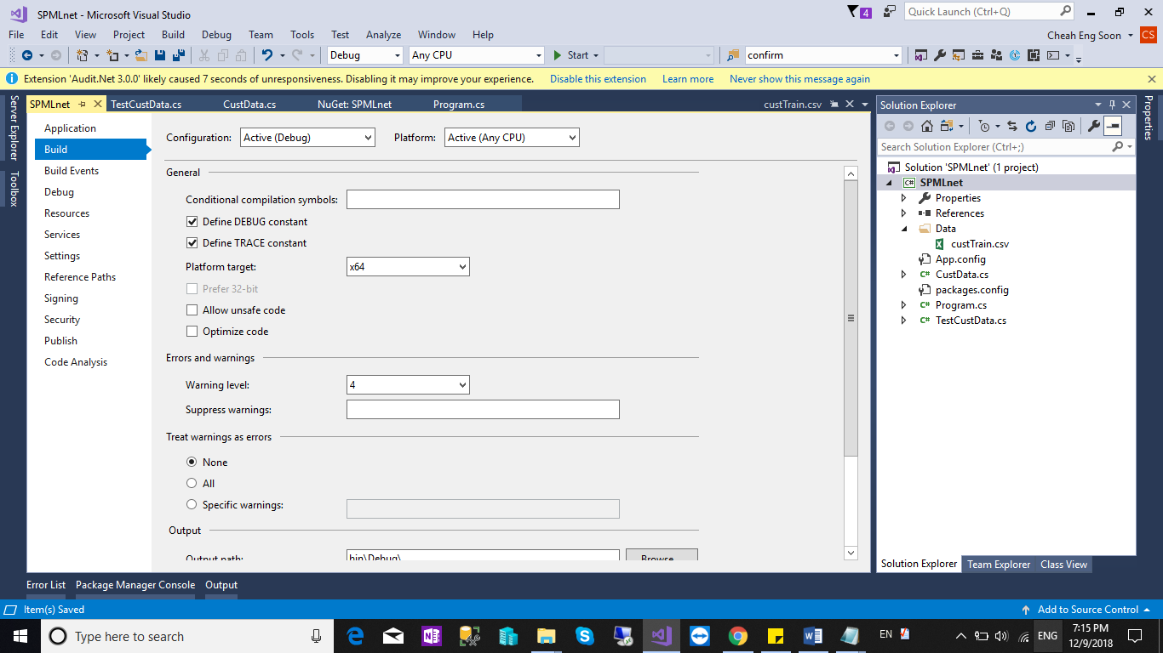

1. Scroll to the bottom and click Advanced. Change the Language version to “C# 7.1”.

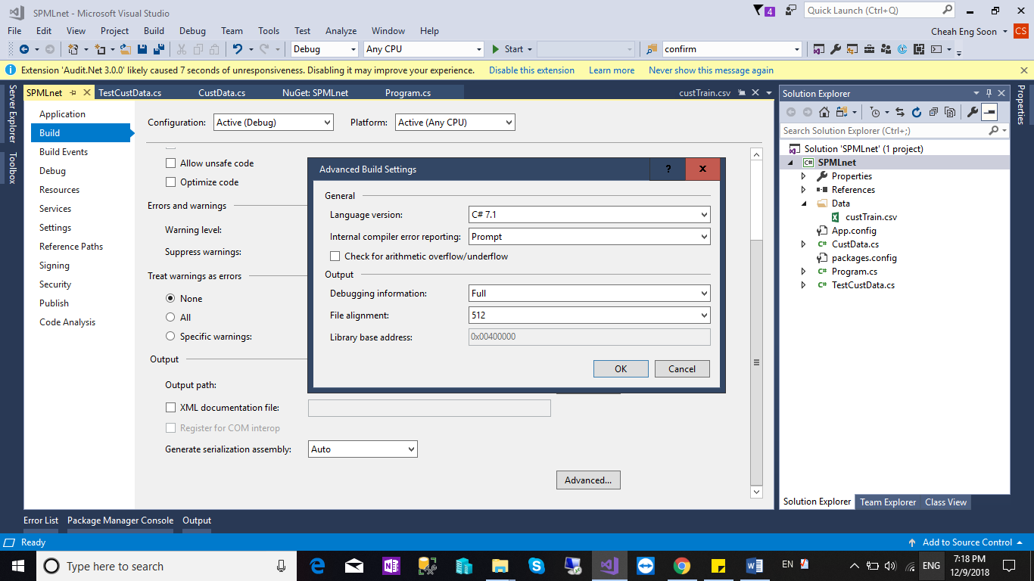

1. Press “F5” for Debug the solutions. The results shown as below.

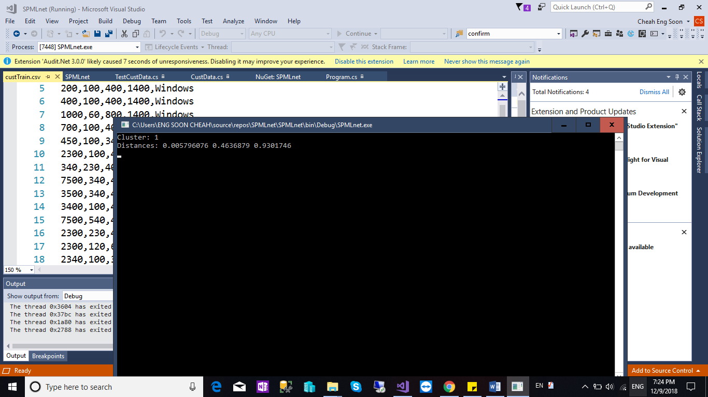

References:

<https://www.c-sharpcorner.com/article/getting-started-with-machine-learning-net-for-clustering-model/>

For other tutorial , you can refer to <https://www.c-sharpcorner.com/article/getting-started-with-machine-learning-dotnet-ml-net/>